Therapeutic Life Story Work

Application form
Professional Diploma
2024-25
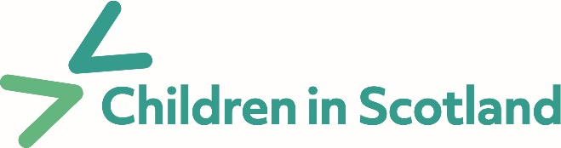
www.tlswi.com
Personal details

Full name:
Job title:
Organisation:
Address:

Email:
Phone:
*Personal Phone:
*We ask for your personal phone number in case we need to contact you due to last minute changes on the course, as you may have your work phone switched off.
Payment information
Contact name:
Contact email:
Postal address:

Purchase Order No.*:
Self-funding Payment Plan: YES/NO

* if required by your organisation

Admission criteria
It is important that you meet these admission criteria if you are submitting an application:

1. It is your responsibility as the student to secure a child, young person, or adult to work with during the period of the course, and that you have necessary permissions to do so.
Do you have the necessary permissions?
YES ☐ | NO ☐

2. Do you have some (direct or indirect) experience of the Child Protection system within the UK (or country of origin for those applying from overseas)?
Please provide one short example:
Click or tap here to enter text.

3. Do you have some proficiency in counselling / therapeutic skills?
Please provide a short summary of previous experience:
Click or tap here to enter text.

4. Do you intend on using therapeutic life story work in a professional capacity and not with any direct care of a child or young person who is in your immediate family care, such as foster, kinship or permanent care?
YES ☐ | NO ☐

5. Please tell us why you would like to enrol on the Professional Diploma course?
(Please write 100 words max.)
Click or tap here to enter text.

Submitting your application
Please submit this application form as soon as possible via email to: admin@tlswi.com using subject line:
TLSW Diploma 24 – 25 – LOCATION* – YOUR NAME
* i.e. London, Birmingham, online

It is important that you also attach the following:
- A short personal bio/CV (1 x A4-page max)
- A professional reference (needs to include contact details for verification)
- A copy of your most recent DBS form (not older than three years)
Invoicing and payment
Once you’ve submitted this form, an invoice for the full fee
(£1,900 + VAT) will be issued to you.
Please remember to secure funding for the course before applying.
Organisations will be invoiced for the full fee payable 30 days from issue of invoice.
If you apply to attend the programme within 30 days of the start, full payment will be required immediately.
TLSWi is able to offer an individual payment plan for those self-funding. This will consist of a non-refundable deposit of 25% followed by three further payments. Details available on request.
You will not be able to start the programme if there is any outstanding debt payable to TLSWi. No award can be achieved following the successful completion of a course if the fees for that course have not been paid in full.
Please note: Refunds of full or part payment* (*if self-funding) will not be possible should you decide not to attend or leave the course early.
If you have any concerns about payment, please contact us prior to applying.
Should your application be unsuccessful, you will receive a full refund.
More information on payments and cancellation policies are provided in the course handbook.
Please note that this registration is NOT a completed booking and doesn't guarantee your place on this course.

If you have any questions, please contact us via admin@tlswi.com

